From Inclusion to Influence: How CoC Governance Shapes Engagement with People with Lived Experience and Local Responses to Homelessness Criminalization

Research Question and Motivation
This study examines how Continuums of Care (CoCs) engage people with lived experience (PLE) of homelessness and whether such engagement shapes local policy and enforcement responses to homelessness. CoCs are central governance structures in local homelessness systems, coordinating service providers, setting priorities, and influencing how homelessness is addressed in practice. Although federal guidance increasingly emphasizes the importance of including PLE in planning and decision-making, the degree to which CoCs institutionalize such engagement likely varies substantially across communities. This variation may matter not only for representation, but also for substantive outcomes—particularly whether communities adopt punitive responses to homelessness, such as anti-camping ordinances, fines, and other forms of criminalization.
This study asks three questions:
- Does the leadership structure of a CoC—particularly whether it is led primarily by a nonprofit organization or a governmental entity—shape the extent to which PLE are included in governance and decision-making?;
- Are higher levels of PLE engagement associated with less punitive local homelessness policies?; and
- Does stronger PLE engagement correspond to lower levels of homelessness-related law enforcement?

Theoretical Framework
The project brings together scholarship on collaborative governance, participatory inclusion, and the criminalization of homelessness. This study argues that CoC leadership structure shapes the architecture of participation, including whether PLE are included on governing boards, advisory bodies, or routine consultation processes. In turn, more meaningful and institutionalized PLE engagement may shift local responses away from punishment and exclusion and toward service-oriented or rights-based approaches. In this framework, PLE engagement functions as both a democratic good and a mechanism that may influence policy outputs and enforcement practices.

Data and Measures
The project draws on annual HUD CoC application materials to build original measures of governance structure and PLE engagement (see below). These documents provide information on lead agency type, board composition, decision-making arrangements, and whether PLE are represented in formal governance processes. From these materials, we will create a PLE engagement index capturing the presence, frequency, and institutional depth of participation.
We will link these data to local ordinances related to the criminalization of homelessness, including anti-camping bans, restrictions on public sleeping, panhandling regulations, and associated penalties such as fines. Where feasible, we will also collect local law-enforcement data, including citations or arrests associated with homelessness-related offenses and records identifying transient or unhoused status.

Research Design
Using a comparative dataset across CoCs, I will test whether nonprofit-led and government-led CoCs differ in the extent of PLE engagement and whether higher engagement is associated with less punitive policy and enforcement outcomes. Depending on data availability, the study will use cross-sectional or panel models and control for factors such as CoC size, local homelessness rates, urbanicity, housing market pressure, and political context.

Contribution
This project contributes to public administration and homelessness governance research in three ways. First, it conceptualizes CoCs as institutions of participatory governance rather than merely service coordination bodies. Second, it develops an original and measurable framework for assessing the institutionalization of lived-experience engagement. Third, it connects PLE inclusion to concrete policy and enforcement outcomes, showing that participation may shape not only who is heard, but also how homelessness is governed.

Annual HUD CoC Application documents – Items to be extracted
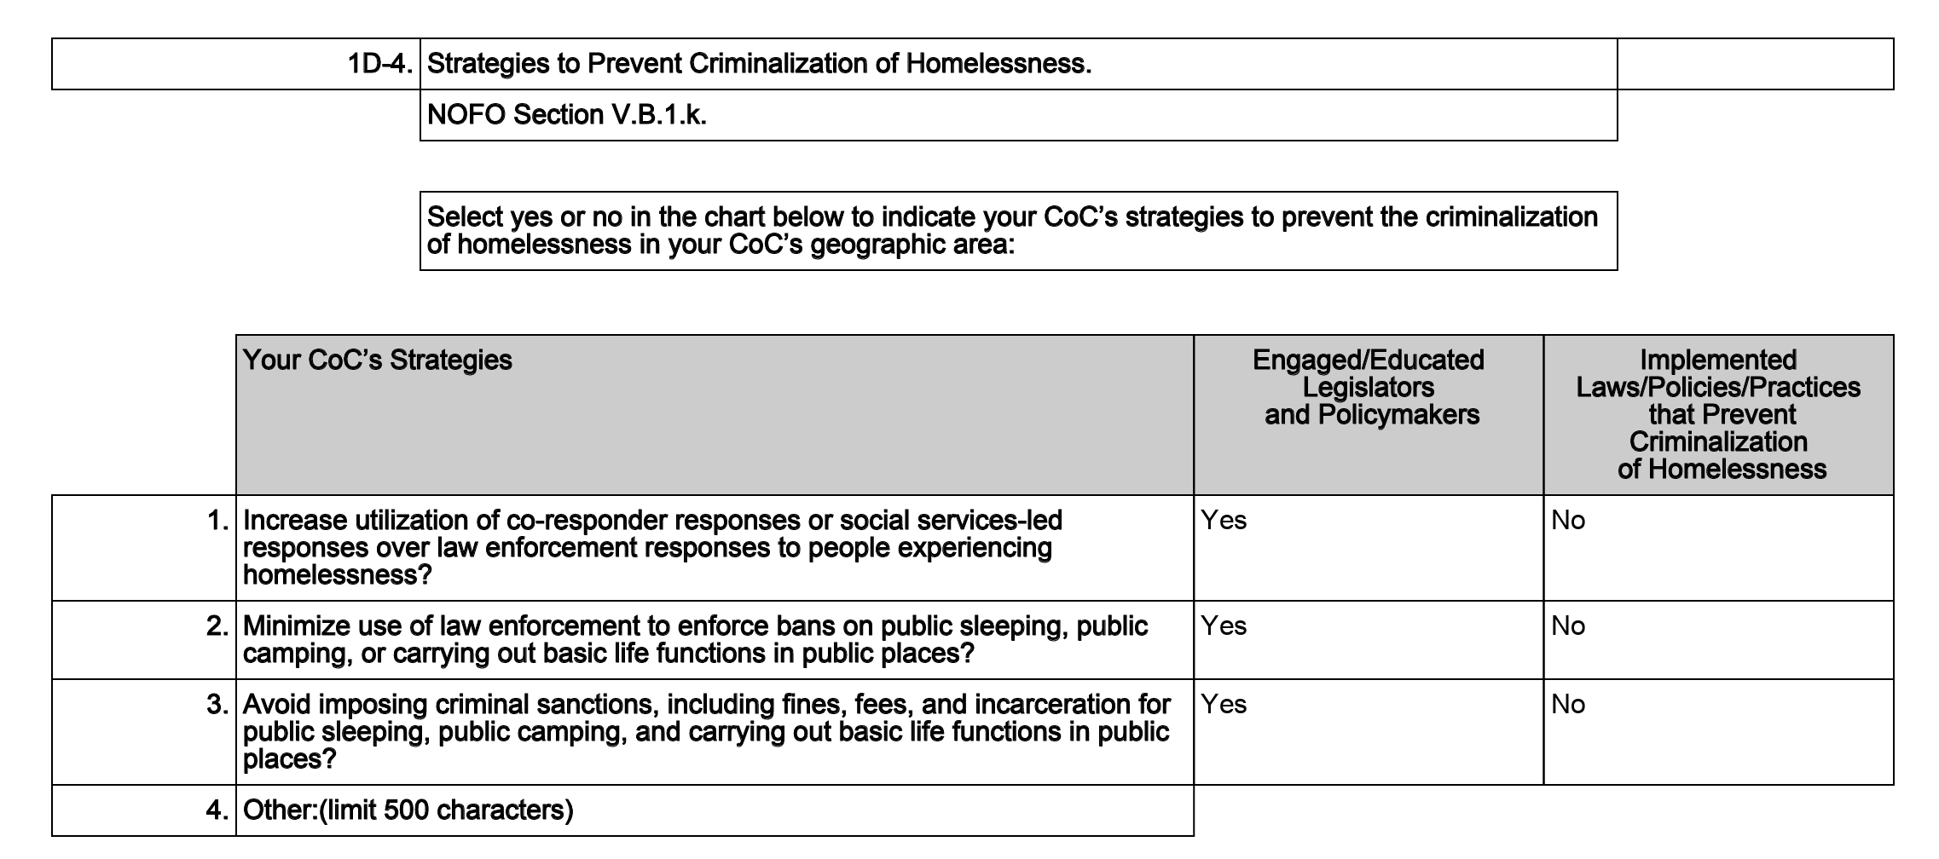
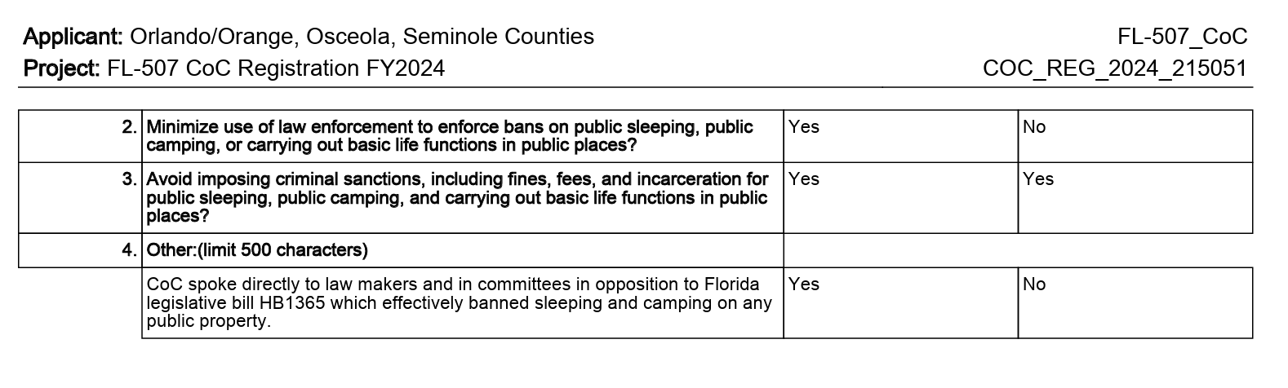
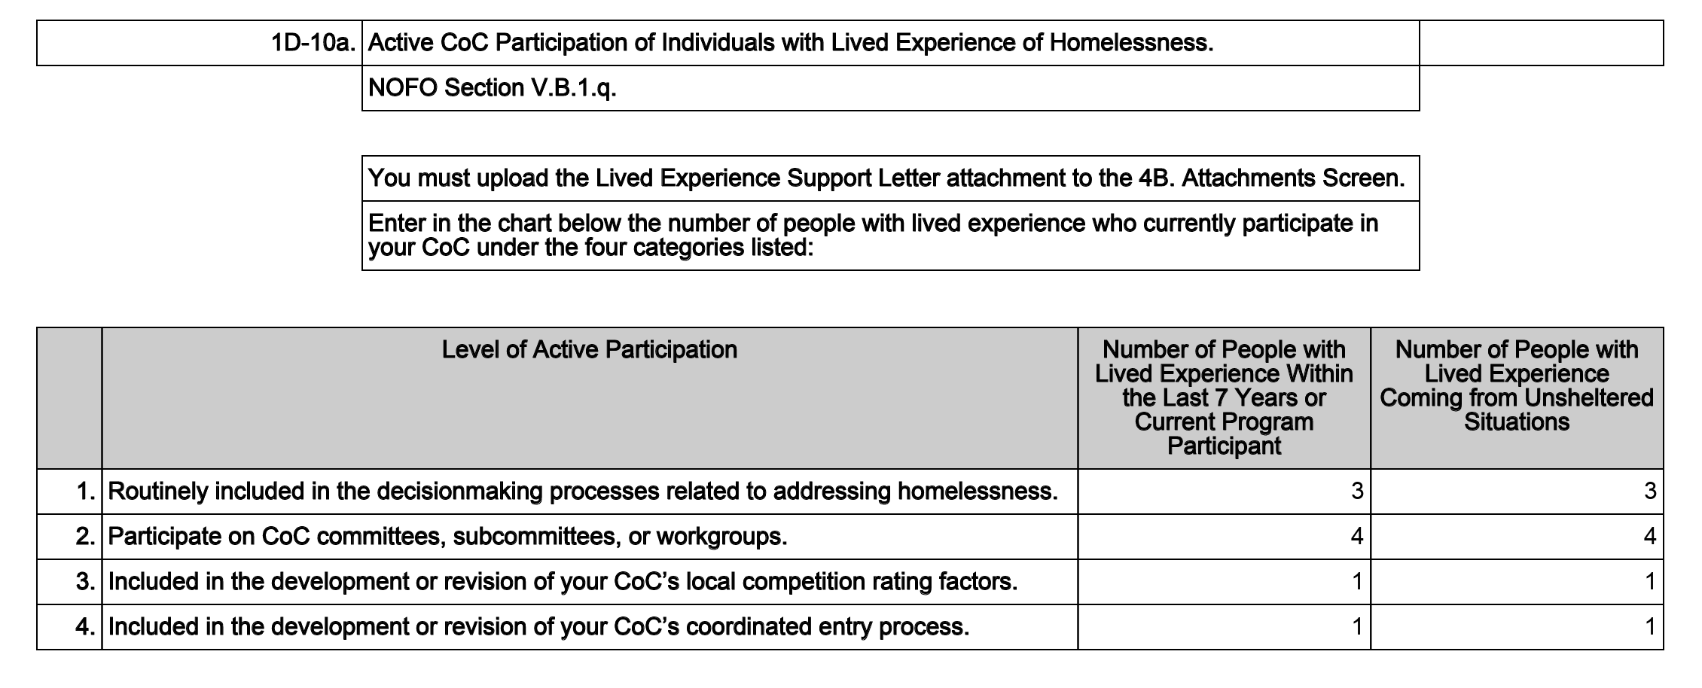
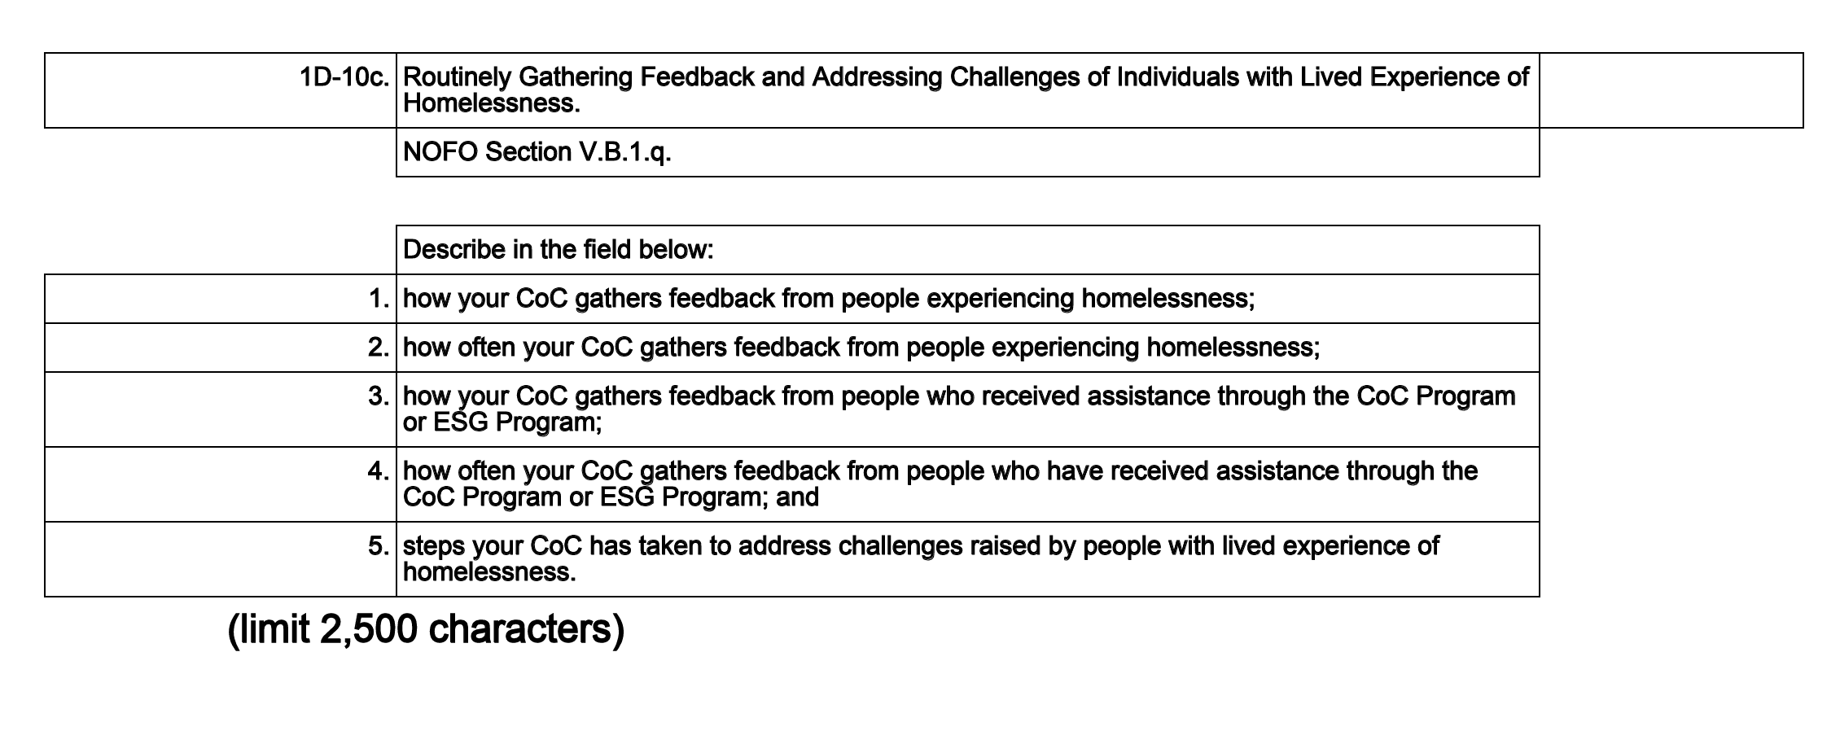
1. The CoC gathers feedback from persons with lived experience by encouraging participation in CoC meetings and working groups and through feedback forms provided to both current and recent clients. 2. The CoC routinely gathers feedback from current and recent clients through a feedback form created by the lead agency. This form gives clients an opportunity to anonymously provide input on our current services as well as suggestions for additional services that would better meet the needs of clients. This form is provided during outreach projects and community resource fairs. Client feedback allows for immediate needs to be addressed and also provides a wider set of data to be used for strategic planning. 3. The Rapid Rehousing Feedback Form requests suggestions for improvements and additional services that may allow us to better serve the needs of future clients in CoC and ESG programs. 4. This form is provided to clients 6 months after receiving assistance through our ESG RRH program or when a client exits the program. This form allows our CoC to gather feedback on what services did and did not help them achieve their goals of stable permanent housing. 5. The CoC has implemented changes to our intake process, street outreach, Community Resource Centers/CE Access Points, and many other programs to address challenges raised by people with lived experience. The CoC has created access points at various locations throughout our catchment area as well as allowing our case managers to travel to clients without transportation to an access point. We have updated our intake form to remove invasive/unnecessary questions. Our CoC has also invited guest providers to the Community Resource Centers/CE Access Points to provide services frequently requested by our clients on site for a one-stop-shop approach. The CoC has future plans for developing and distributing customer satisfaction surveys that will be made available to all CoC-program participants and not just recent clients. These surveys will be available at service agencies and online allowing for anonymous submissions. The goal is to utilize candid feedback to assess the daily experiences of clients participating in CoC-funded programs. This data will be used to measure successes and identify areas for further improvement, trauma-informed training, better data collection, or areas for increased collaboration.

